Test Case: tc002_SPX_Dev5_Crear_Requisicion_Spot_Con_FAD_Tipo_Cobro_CC
Step 1 - Enter username and password and click to button Enter : Credentials Entered
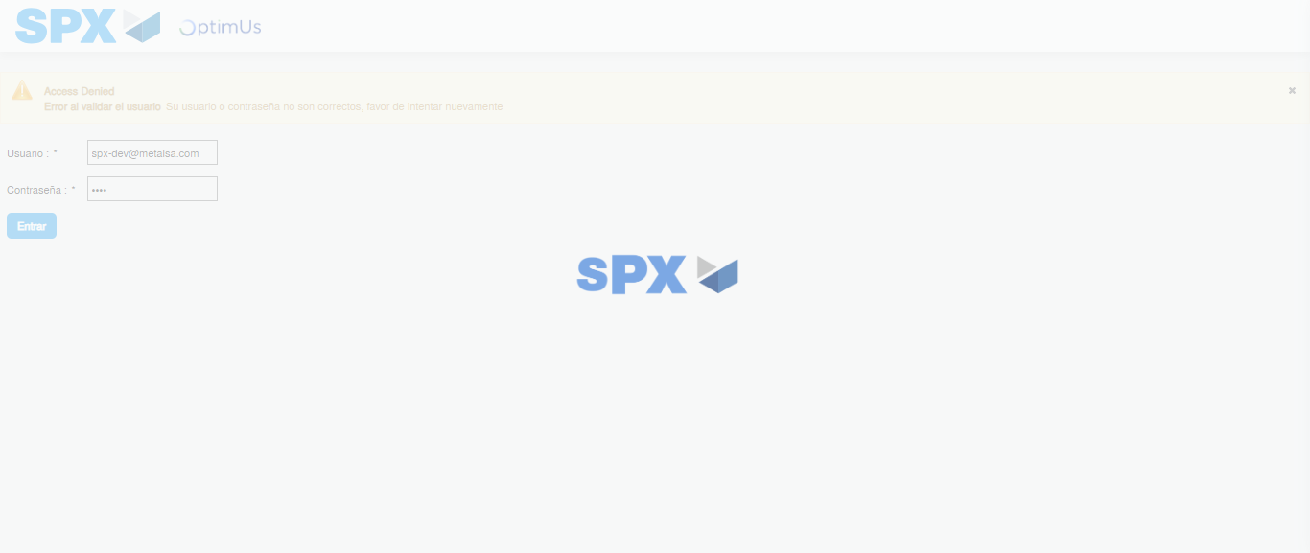Image file-name: QC_Testing-tc002_SPX_Dev5_Crear_Requisicion_Spot_Con_FAD_Tipo_Cobro_CC-1783355574971

Step 2 - Select to UEN and Access to Spot Buy Requisitions : UEN Correctly selected and Correct access
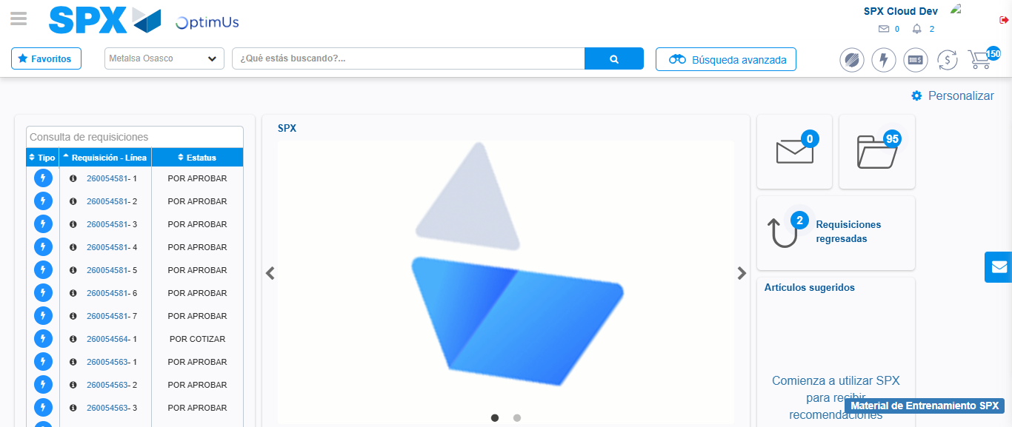Image file-name: QC_Testing-tc002_SPX_Dev5_Crear_Requisicion_Spot_Con_FAD_Tipo_Cobro_CC-1783355599873

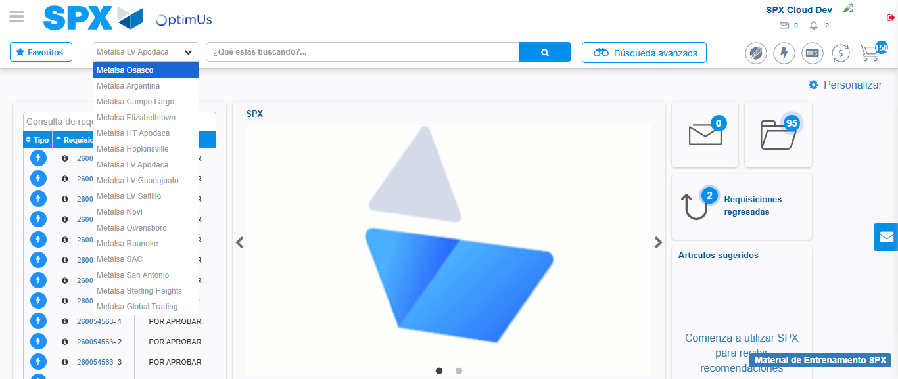Image file-name: QC_Testing-tc002_SPX_Dev5_Crear_Requisicion_Spot_Con_FAD_Tipo_Cobro_CC-1783355602608

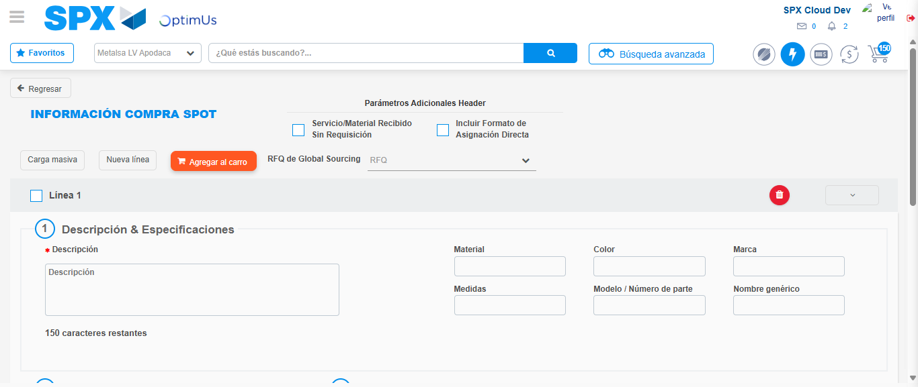Image file-name: QC_Testing-tc002_SPX_Dev5_Crear_Requisicion_Spot_Con_FAD_Tipo_Cobro_CC-1783355628433

Step 3 - Add FAD to Requisition: FAD Successfully Added
Image file-name: QC_Testing-tc002_SPX_Dev5_Crear_Requisicion_Spot_Con_FAD_Tipo_Cobro_CC-1783355628642

Image file-name: QC_Testing-tc002_SPX_Dev5_Crear_Requisicion_Spot_Con_FAD_Tipo_Cobro_CC-1783355628847

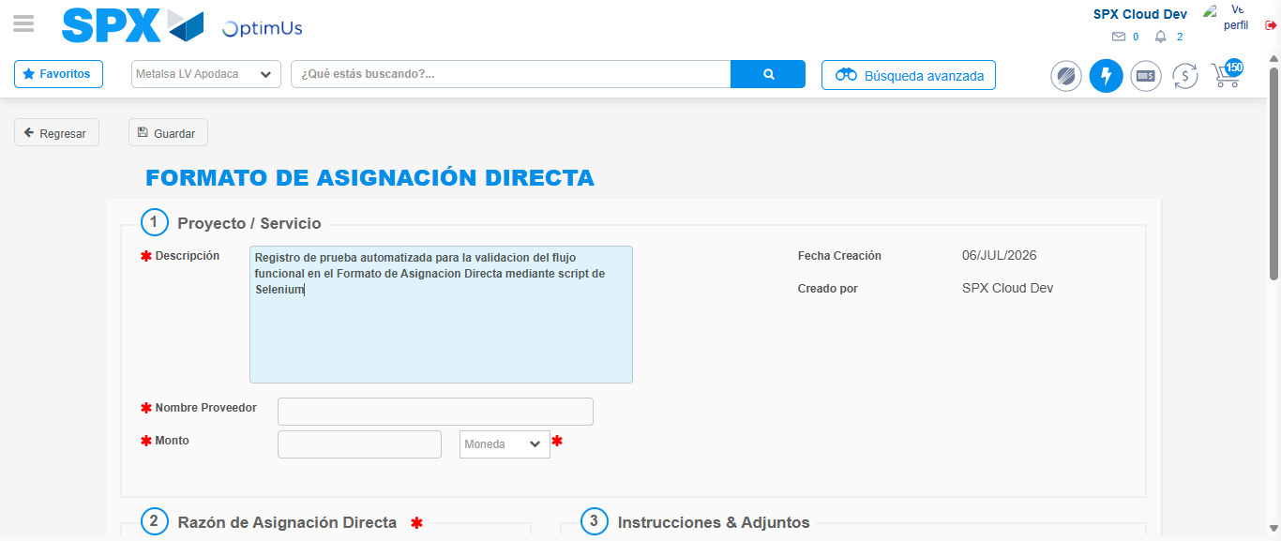Image file-name: QC_Testing-tc002_SPX_Dev5_Crear_Requisicion_Spot_Con_FAD_Tipo_Cobro_CC-1783355631577

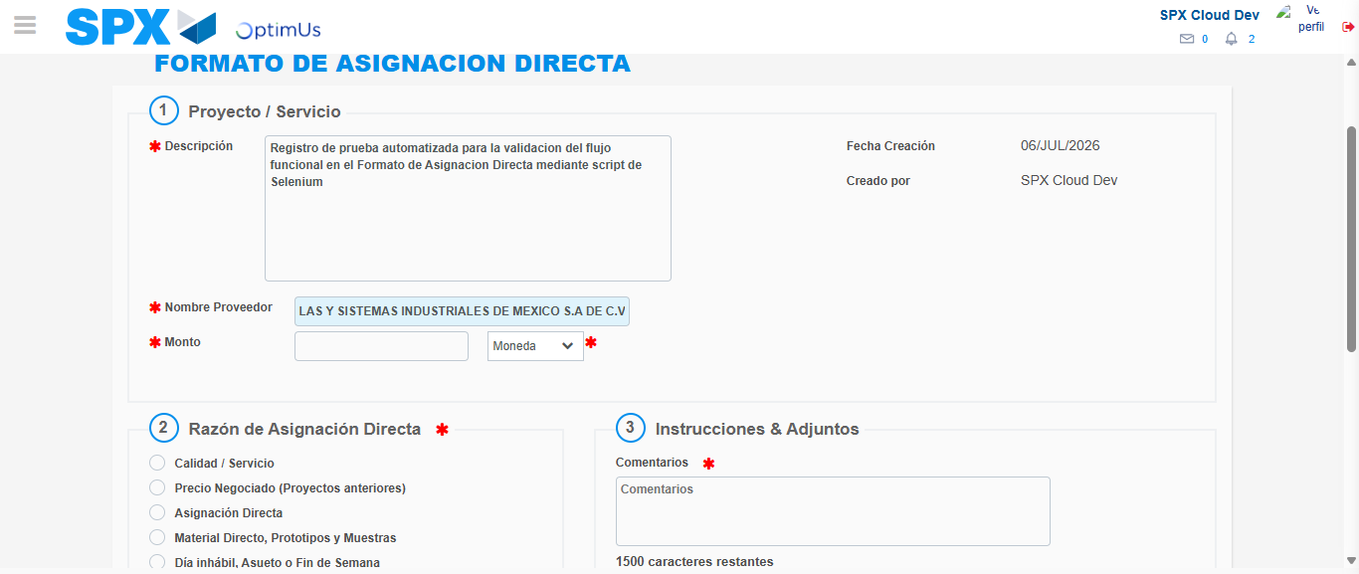Image file-name: QC_Testing-tc002_SPX_Dev5_Crear_Requisicion_Spot_Con_FAD_Tipo_Cobro_CC-1783355638765

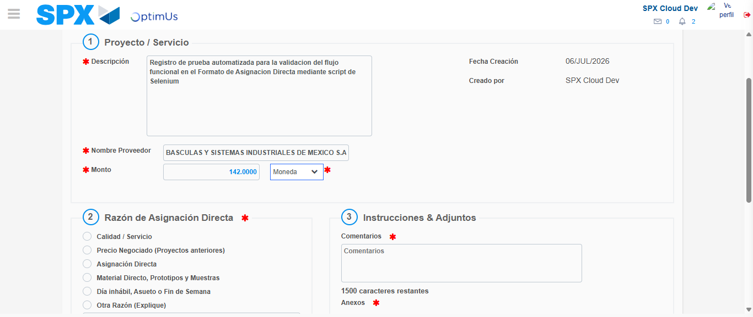Image file-name: QC_Testing-tc002_SPX_Dev5_Crear_Requisicion_Spot_Con_FAD_Tipo_Cobro_CC-1783355639192

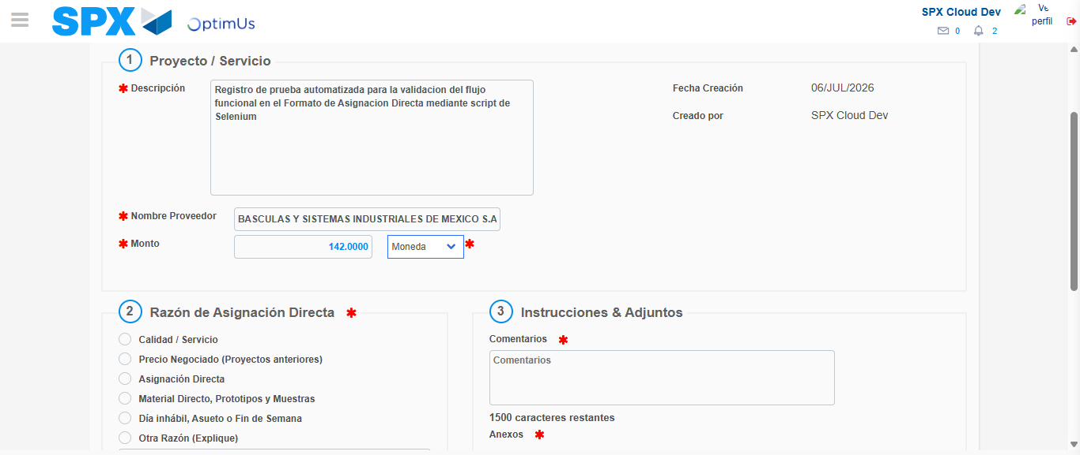Image file-name: QC_Testing-tc002_SPX_Dev5_Crear_Requisicion_Spot_Con_FAD_Tipo_Cobro_CC-1783355639393

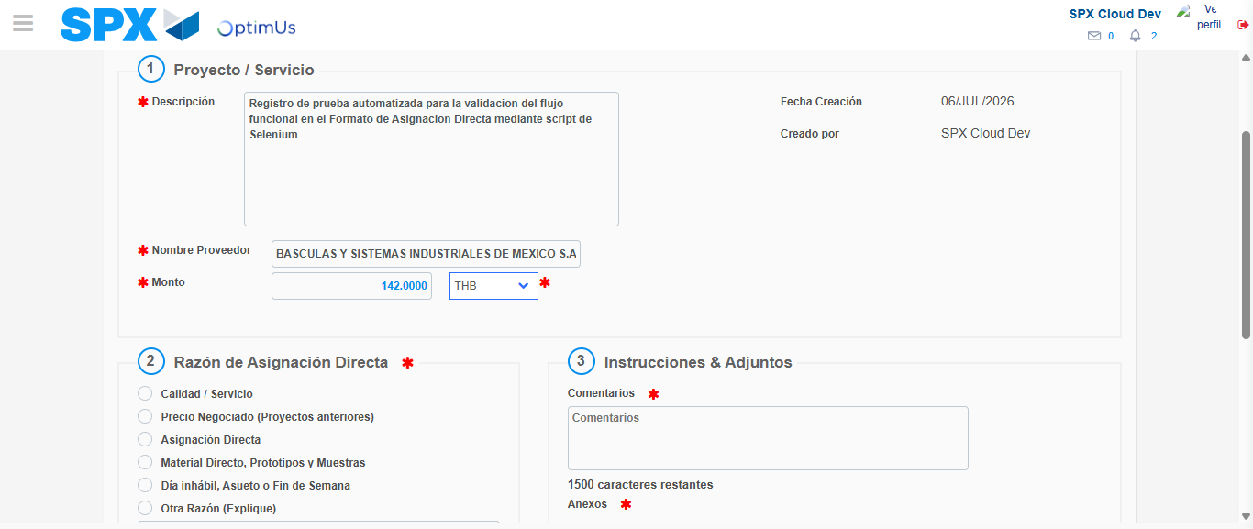Image file-name: QC_Testing-tc002_SPX_Dev5_Crear_Requisicion_Spot_Con_FAD_Tipo_Cobro_CC-1783355639769

Image file-name: QC_Testing-tc002_SPX_Dev5_Crear_Requisicion_Spot_Con_FAD_Tipo_Cobro_CC-1783355639951

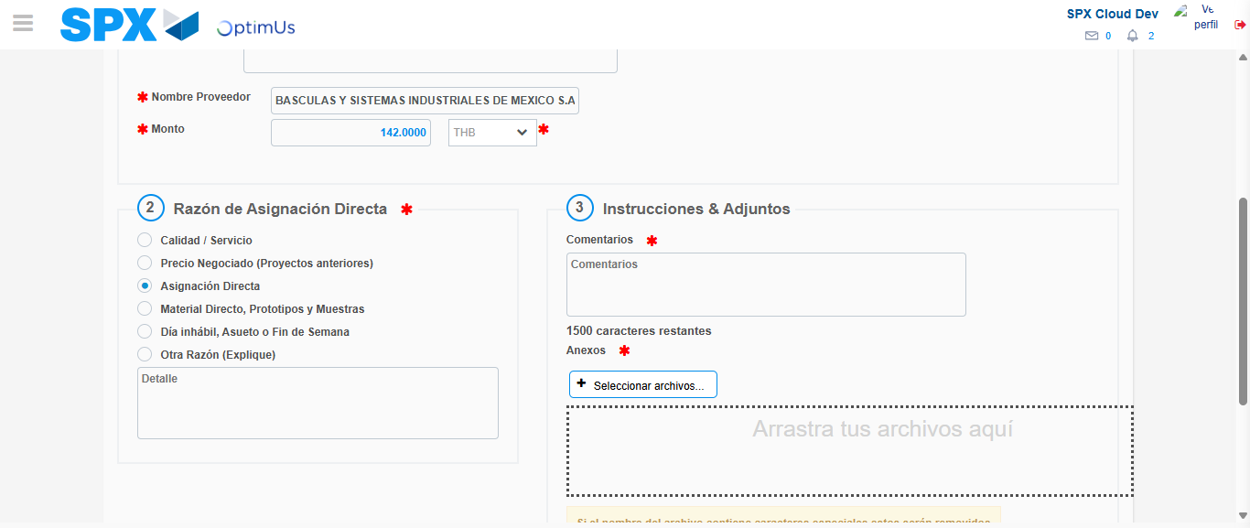Image file-name: QC_Testing-tc002_SPX_Dev5_Crear_Requisicion_Spot_Con_FAD_Tipo_Cobro_CC-1783355640819

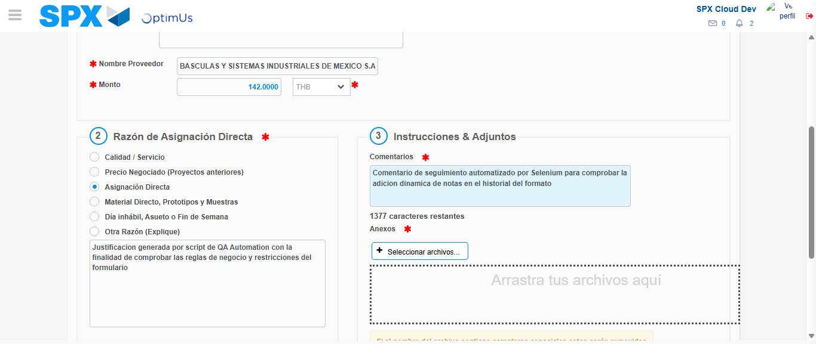Image file-name: QC_Testing-tc002_SPX_Dev5_Crear_Requisicion_Spot_Con_FAD_Tipo_Cobro_CC-1783355651801

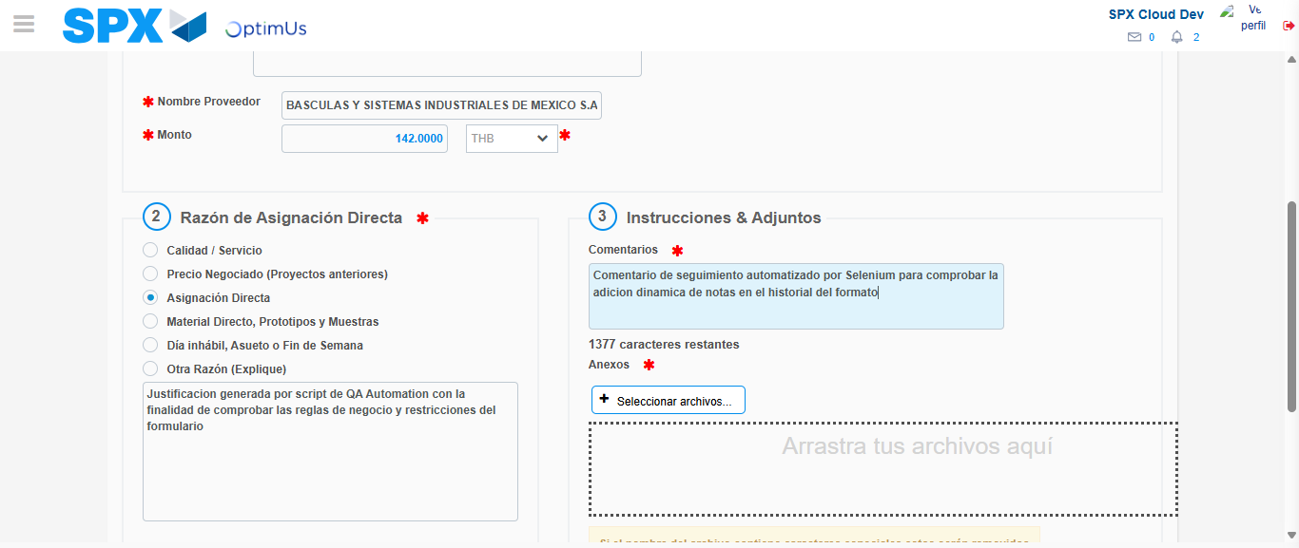Image file-name: QC_Testing-tc002_SPX_Dev5_Crear_Requisicion_Spot_Con_FAD_Tipo_Cobro_CC-1783355652455

Step 4 - Data Capture Spot Buy Requisition: Data captured correctly
Image file-name: QC_Testing-tc002_SPX_Dev5_Crear_Requisicion_Spot_Con_FAD_Tipo_Cobro_CC-1783355628642

Image file-name: QC_Testing-tc002_SPX_Dev5_Crear_Requisicion_Spot_Con_FAD_Tipo_Cobro_CC-1783355628847

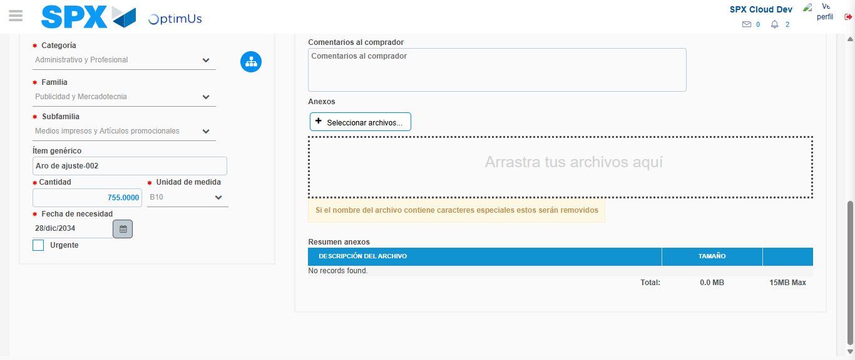Image file-name: QC_Testing-tc002_SPX_Dev5_Crear_Requisicion_Spot_Con_FAD_Tipo_Cobro_CC-1783355662921

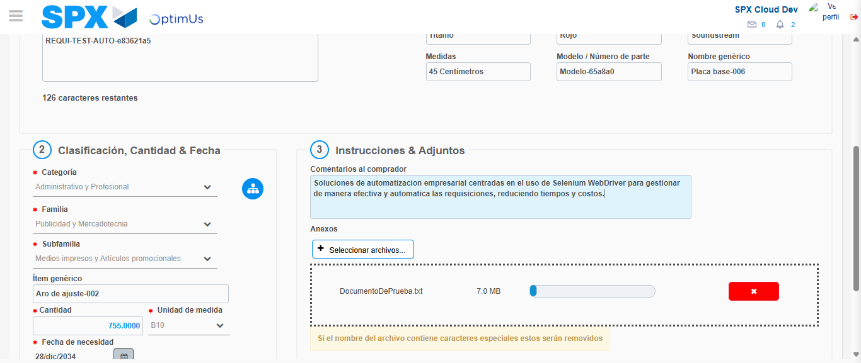Image file-name: QC_Testing-tc002_SPX_Dev5_Crear_Requisicion_Spot_Con_FAD_Tipo_Cobro_CC-1783355663632

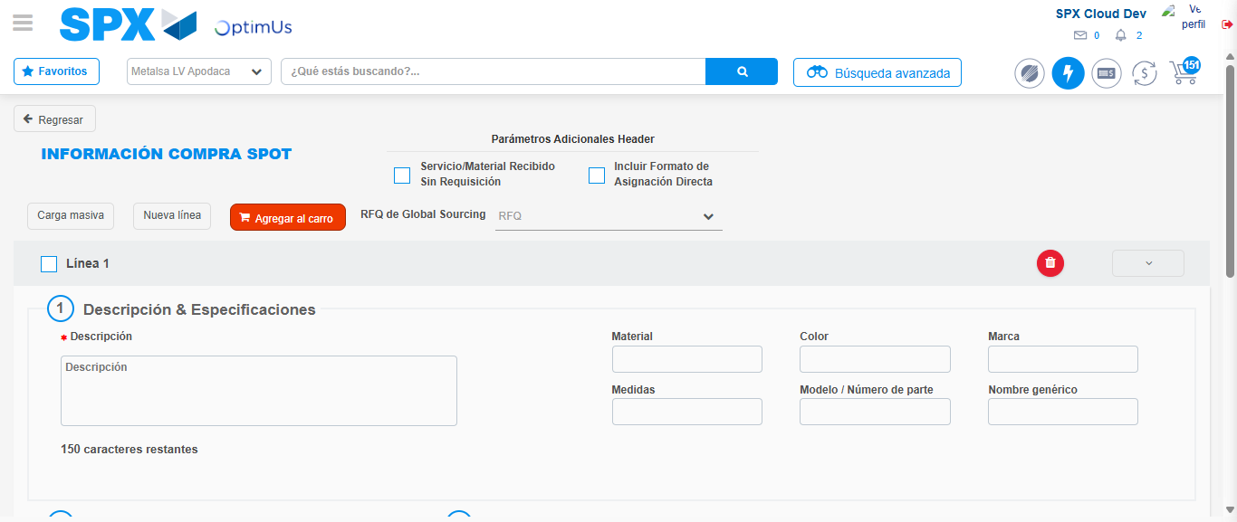Image file-name: QC_Testing-tc002_SPX_Dev5_Crear_Requisicion_Spot_Con_FAD_Tipo_Cobro_CC-1783355672234

Step 8 - Return to Main Page SPX : Return to Main Page SPX
Image file-name: QC_Testing-tc002_SPX_Dev5_Crear_Requisicion_Spot_Con_FAD_Tipo_Cobro_CC-1783355599873

Image file-name: QC_Testing-tc002_SPX_Dev5_Crear_Requisicion_Spot_Con_FAD_Tipo_Cobro_CC-1783355602608

Image file-name: QC_Testing-tc002_SPX_Dev5_Crear_Requisicion_Spot_Con_FAD_Tipo_Cobro_CC-1783355628433

Image file-name: QC_Testing-tc002_SPX_Dev5_Crear_Requisicion_Spot_Con_FAD_Tipo_Cobro_CC-1783355674449

Image file-name: QC_Testing-tc002_SPX_Dev5_Crear_Requisicion_Spot_Con_FAD_Tipo_Cobro_CC-1783355674638

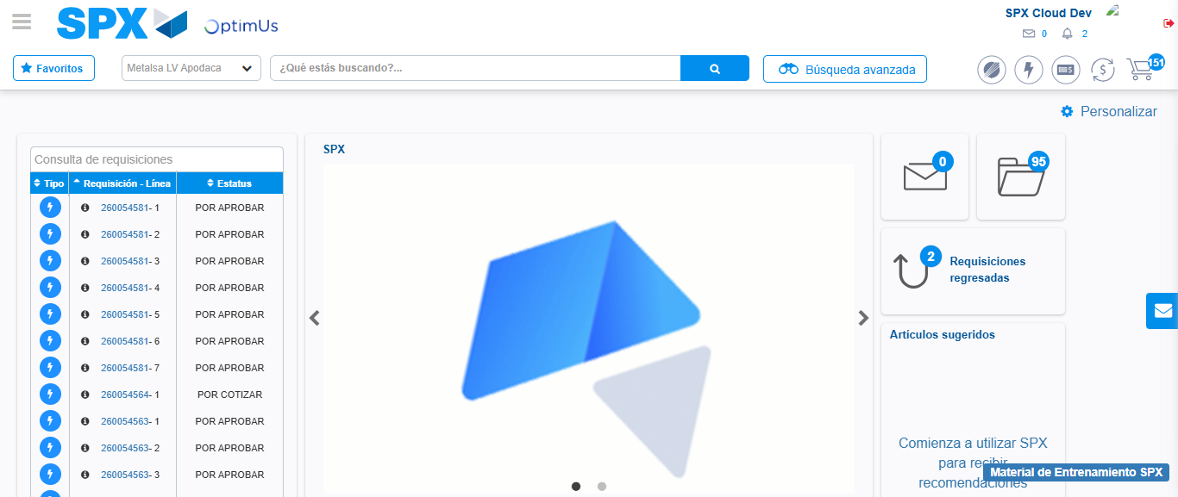Image file-name: QC_Testing-tc002_SPX_Dev5_Crear_Requisicion_Spot_Con_FAD_Tipo_Cobro_CC-1783355695977

Step 9 - Log Out : Log Out SPX
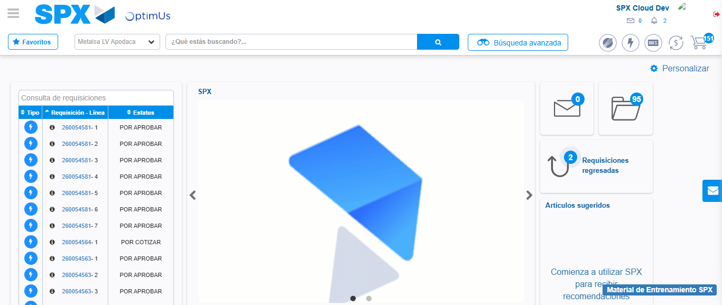Image file-name: QC_Testing-tc002_SPX_Dev5_Crear_Requisicion_Spot_Con_FAD_Tipo_Cobro_CC-1783355696263

